Software Requirements Specification

for

Hospital Management System

Version 1.0 approved

Prepared by Vatsal Jagani , Herma Sahdevsinh

Computer Engineering Department, FOT, DDU.

15th Aug, 2016

Table of Contents

Table of Contents ii

Revision History ii

1. Introduction 1

1.1 Purpose 1

1.2 Document Conventions 1

1.3 Intended Audience and Reading Suggestions 1

1.4 Product Scope 1

1.5 References 1

2. Overall Description 2

2.1 Product Perspective 2

2.2 Product Functions 2

2.3 User Classes and Characteristics 3

2.4 Operating Environment 4

2.5 Design and Implementation Constraints 4

2.6 User Documentation 4

2.7 Assumptions and Dependencies 5

3. External Interface Requirements 5

3.1 User Interfaces 5

3.2 Hardware Interfaces 5

3.3 Software Interfaces 5

3.4 Communications Interfaces 5

4. System Features 5

4.1 Patient Management System 6

4.2 Doctor consultancy System 6

4.3 Staff Management System……………………………………………………………………...4

4.4 Medical Management System…………………………………………………………………...4

4.5 Laboratory Automation…..……………………………………………………………………...4

4.6 Billing System…………………………………………………………………………………...4

4.7 Emergancy Service……………………………………………………………………………...4

4.8 Webpage for Hospital Info……………………………………………………………………...4

5. Other Nonfunctional Requirements 11

5.1 Performance Requirements 11

5.2 Security Requirements 11

5.3 Software Quality Attributes 12

5.4 Business Rules 12

6. Other Requirements 12

Appendix A: Glossary 12

Appendix B: Analysis Models 12

Appendix C: To Be Determined List 13

Revision History

|  |  |  |  |
| --- | --- | --- | --- |
| **Name** | **Date** | **Reason For Changes** | **Version** |
|  |  |  |  |
|  |  |  |  |

# Introduction

## Purpose

Purpose of this document is to present detailed description of Hospital Management System. It will explain different features and functionality will provide by the system. This document useful for both stakeholders (Managing staff of hospital, patient) and developer of the system. This document shows what system will do, and how it will do.

## Document Conventions

In this document, following conventions were followed.

1. Capital letter used for emphasis mean of word or special phrase.

## Intended Audience and Reading Suggestions

The intended audience includes all the stakeholders (Manager, Doctor, Patient, Receptionist, Registration Desk staff, etc.) and developer including project Manager and database administrative.

## Product Scope

It is specialized Hospital for Cancer. More Specifically system will handled two types of cancer treatment records.

1. Chemo Therapy
2. Treatment By Operation and Radiology

System will also can handled maintain laboratory reports of the patient. System will have basic functionality of Medical-Store Management System. The system also contain billing system for patient contains Doctors Fee, Laboratory Fee, Room Fee, etc. The will also have feature of work duty or work shift allocation for Hospital staff. System will show information of patient reports online and patient can view those reports.

## References

IEEE. IEEE Std 830-1998 IEEE Recommended Practice for Software Requirements Specifications. IEEE Computer Society, 1998.

# Overall Description

## Product Perspective

The Hospital Management system is manage many thing with many users of the system, as describe in diagram and also in further chapters.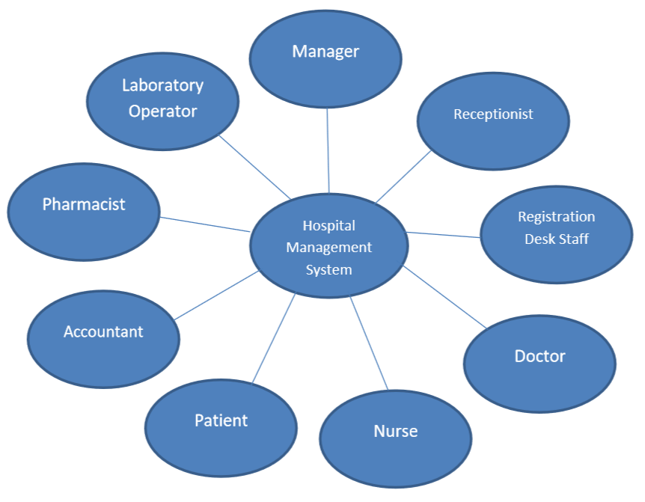

## Product Functions

Major functionality of System is following :

1. Appointment System
2. Patient Record Management System

2. Billing System

3. Doctor treatment report

4. Laboratory Record

5. Medical-Store management System (Basic)

6. Staff Management System

7. Online Help ( Treatments, Appointment, Other Information …..)

*** More specifically functionality describe in section – 4.

## User Classes and Characteristics

This system will have many stakeholders or users. As shown below.

1. Manager
   * All Managers have post secondary education related to general business administration.
   * Every administrator have to take basic computer training.
   * Managers are responsible for assign shift schedule of staff of hospital.
2. Receptionist
   * Receptionist must have basic training of operate computer.
   * Receptionist have to give basic info of patient, nurse and doctor to visitors.
   * They also responsible for emergency services.
3. Registration Desk Staff
   * Receptionist must have basic training of operate computer.
   * They are responsible for appoint Doctor to patient and assign room to patient.
   * They handle check in &check out of patient.
4. Doctor
   * Doctor can add/modify treatment report of patient.
5. Nurse
   * Nurse only can see their work duty info.
6. Accountant
   * Manage billing system of Hospital.
   * They all have to have basic education related to accounting and basic computer operate.
7. Laboratory Operator
   * For handling laboratory of hospital.
   * Proper skill must have for operating laboratory.
8. Pharmacist
   * For managing medical store.
   * Must have education about pharmacy and medicine.
9. Patient
   * Any patient / people must have view of hospital and have online available.
   * Patient report also must be available for patient online.

## Operating Environment

For Server Requirements

Operating Environment on which server of the System can work must have proper memory available. Processor should handle no of user online at a time (at least 150 users at a time). 4 GB Main memory must require in server computer.

For client device browser must be installed on their device.

Chrome version – 25.0 (and up)

Firefox version – 1.5 (and up)

## Design and Implementation Constraints

Below are the technologies which will use in this system implementation.

1. Foreground Design – Html, CSS, Bootstrap, Javascript.

2. Background – ASP.NET with language C# .

3. Database – SQL server supported by Microsoft Visual Studio 2015.

## User Documentation

It is very easy to use this system as it is web based application. For further query users can contact developer team.

## Assumptions and Dependencies

All the data entered will be correct and up-to-date. This software package is developed using ASP.NET (language – C#) as front end which is supported by Microsoft corporation, SQL server as the back end which is supported by Microsoft Visual studio 2015. Whole application will create in Microsoft Visual Studio 2015.

# External Interface Requirements

## User Interfaces

User Interface for Hospital Management System is fully web based. User need browser to use the system. System will provide easy graphical user interface, using Html, CSS, Bootstrap, and Javascript.

## Hardware Interfaces

As a hardware interface user just require is device which supports browser implementation. The system can work on any latest browser efficiently.

## Software Interfaces

As it is web based application, User can open Hospital Management System into any browser. Device used by user must be connected with server and database either directly or indirectly.

## Communications Interfaces

User device must be connected with server(host) and server must connected with database server via any kind of network.

# System Features

System features given as below,

1. Patient record management
2. Doctor consultancy system
3. Staff management system
4. Medical store management system
5. Laboratory automation
6. Billing system
7. Information System at Reception Area
8. web page for Hospital management system

## Patient record management

4.1.1 Description and Priority

In HMS this function provides registration of patient and it is also provide check-in and check-out patient by registration desk staff.

** Priority 1st .

4.1.2 Stimulus/Response Sequences

Registration Desk Staff can add new patient details and it will assign unique patient id and by that it will maintain the record of patient.

4.1.3 Functional Requirements

R.1.1 Registration

HMS provides registration system for new patient.

INPUT : patient details

PROCESS : assign patient ID and add patient to database.

Insert into patients (pid,name,contact_no,address,city,marital_status,gender,birthdate,reg_by,reg_date) values(patientid_seq.nextval,:CONTACT,:ADDRESS,:CITY,:MARITAL_STATUS,:GENDER,:BIRTHDATE,:REG_BY,:REG_DATE);

R.1.2 Patient check-in & check-out

HMS allows registration desk staff to check-in & check-out of new or old patient.

INPUT : date of check-in & check-out, room no. assigned to patient.

PROCESS : add details to database.

Insert into checkin (pid,name,checkin_no,room,checkin_by,in_time) values(:PATIENTID,checkin_seq.nextval,:ROOM,:CHECKIN_NO,:CHECKIN_BY,:CHECKIN-DATE);

R.1.3 Patient Info

HMS allows patient to see their reports and treatment reports online.

INPUT : patient id

OUTPUT : all reports for patient

## Doctor consultancy system

4.2.1 Description and Priority

In HSM this function provides consult proper doctor with patient and also allows doctors to add treatment, medicine details for patient.

** Priority 2nd .

4.2.2 Stimulus/Response Sequences

Doctor will add treatment details of patient. After that system automatically creates the treatment report.

4.2.3 Functional Requirements

R.2.1 Doctor Treatment

HMS allows Doctor to add treatment, medicine details for patient.

INPUT : patient treatment details.

PROCESS : add patient treatment details to system.

OUTPUT : formatted treatment Report

## Staff Management System

4.3.1 Description and Priority

HSM will allow manager to maintain records related to staff and work allocation of the staff.

** Priority 3rd .

4.3.2 Stimulus/Response Sequences

Manager can add new member of the staff and system will assign id to employee. And manager will assign the job to particular staff and he can also remove the staff member.

4.3.3 Functional Requirements

R.3.1 Add new Employee

HMS allows manager to add new staff member.

INPUT : details of new employee

PROCESS : assign employee id.

R.3.2 Remove Employee

HMS also allows Manger to remove any employee.

INPUT : employee id

PROCESS : remove employee details from database of specified.

R.3.3 Job assign to Employee

HMS allows manager to assign job to employee which can see by all employees on their account.

INPUT : job assignment details

PROCESS : assign job.

## Medical store management system

4.4.1 Description and Priority

In HSM this function provides all the details of medicine which is taken by the patient and calculate bill for that.

** Priority 4th .

4.4.2 Stimulus/Response Sequences

As per the prescription given by the doctor, pharmacist give appropriate medicine and system will generate the bill.

4.4.3 Functional Requirements

R.4.1 Medical store management

HMS allows store pharmacist to add all the details of the medicine and calculation of their cost automatically.

INPUT : medicine details for patient

PROCESS : create bill for medicines and count total

OUTPUT : formatted bill

## Laboratory Automation

4.5.1 Description and Priority

In HMS this function provides laboratory operator to add laboratory reports for any patient.

** Priority 5th .

4.5.2 Stimulus/Response Sequences

As per the doctor report laboratory operator will do appropriate test on patient and report will sync with database and expense for that also considered by system.

4.5.3 Functional Requirements

R.5.1 Add patient report

HMS allows laboratory operator to add patient report into database of that particular system.

INPUT : patient laboratory report details

PROCESS : add report to database sync with appropriate patient.

OUTPUT : formatted report

R.5.2 Format Laboratory Report

HMS should automatically format laboratory report as per need.

INPUT : Laboratory report details

PROCESS : format laboratory report.

OUTPUT : Formatted Laboratory Report

## Billing System

4.6.1 Description and Priority

In HMS this function provides interface by which accountant can easily create bill for patient.

** Priority 6th .

4.6.2 Stimulus/Response Sequences

As per the doctor charge, hospital charge, laboratory charge and medical bill it will generate final bill which is contain all over expense of that patient.

4.6.3 Functional Requirements

R.6.1 Bill generation

HMS allows accountant to create whole bill and generate formatted bill.

INPUT : charges for hospital & doctor and medicine & laboratory bill

PROCESS : create final bill count total expense.

OUTPUT : formatted bill

R.6.1 Adding Bill Status

Sometimes it is needed that bill will not paid at that time HMS allow accountant.

INPUT : Bill status

PROCESS : add bill status.

OUTPUT : Final bill with status

## Information System

4.7.1 Description and Priority

HMS provides facility through which receptionist can get the information from system for visitor.

** Priority 7th .

4.7.2 Stimulus/Response Sequences

System will give all staff, doctors, patient basic info to receptionist as per the request.

4.7.3 Functional Requirements

R.7.1 Gathering Information

HMS allows receptionist to get basic info of all staff, doctors and patient.

INPUT : search key

PROCESS : get the details.

OUTPUT : Details

R.7.1 Displaying Information

Info will display in proper and well-mannered format.

INPUT : information

PROCESS : format information.

OUTPUT : Formatted Details

## Webpage for Hospital Information

Hospital information must be available online so, patient can view it. Patient can get the details of the Hospital, Doctors & treatment from anywhere.

** Priority 8th .

# Other Nonfunctional Requirements

## Performance Requirements

1. Response Time

The system should give response within 15 sec.

1. Capacity

The system should store and manage at least 1 year of records of patient and staff.

1. User-Interface

The system should provide better user interaction.

## Security Requirements

1. Authentication

The system should protected by username and password, for authenticate every user of the system.

1. Authorization

The system should also maintain authorization. One user cannot enter into other’s area. Manager have maximum privileges, other user like Doctor and Nurse, Pharmacist have limited privileges.

1. Integrity

Data should be safe from out-side access, like cookie stored by the system must not access by other.

## Software Quality Attributes

Quality attributes like: adaptability, availability, correctness, flexibility, interoperability, maintainability, portability, reliability, reusability, robustness, testability, and usability, etc. must be verified.

## Business Rules

Every user have their own work area they can work only in that area.

1. Receptionist - Get the info about Patient, Doctor and Nurse.
2. Registration Desk Staff - Add, Remove, Modify Patient info.
3. Nurse - Info about only their own work duty.
4. Doctor - Add, Remove, Modify patient treatment info.
5. Manager - Assign work duty to Nurse and other staff.
6. Pharmacist - Add, Remove, Modify patient medical bill info.
7. Laboratory Operator - Add, Remove, Modify patient laboratory report.
8. Accountant - Handling Billing System.
9. Patient - Only view their reports.

# Other Requirements

As it is web application, database should be always connected with the server, otherwise system cannot work. Device in which you want to use system, must be connected with server via any network (ex-internet).

Appendix A: Glossary

|  |  |
| --- | --- |
| **Term** | **Definition** |
| Author | Person writing this document to be reviewed. In case of multiple authors. |
| Database | Collection of all the information monitored by this system. |
| Receptionist | A person describe earlier in this document |
| Registration Desk Staff | A person describe earlier in this document |
| Nurse | A person describe earlier in this document |
| Doctor | A person describe earlier in this document |
| Pharmacist | A person describe earlier in this document |
| Manager | A person describe earlier in this document |
| Laboratory Operator | A person describe earlier in this document |
| Staff | It includes All the employee of the hospital except Doctors and Manager. |
| Software Requirements Specification | A document that completely describes all of the functions of a proposed system and the constraints under which it must operate. This document. |
| Stakeholder | Any person with an interest in the project who is not a developer. |
| User | Who can login to system and use |

Appendix B: Analysis Models

Appendix C: To Be Determined List